Alexander Schleicher K8

1/4 scale 3.75m (148") span for 4/5 channel. Flair kit number FL1051.

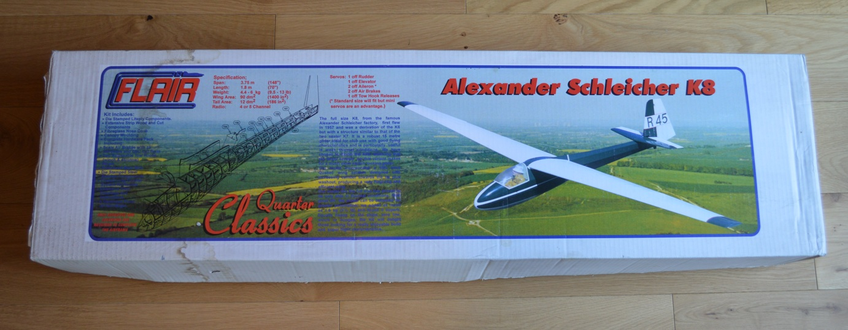

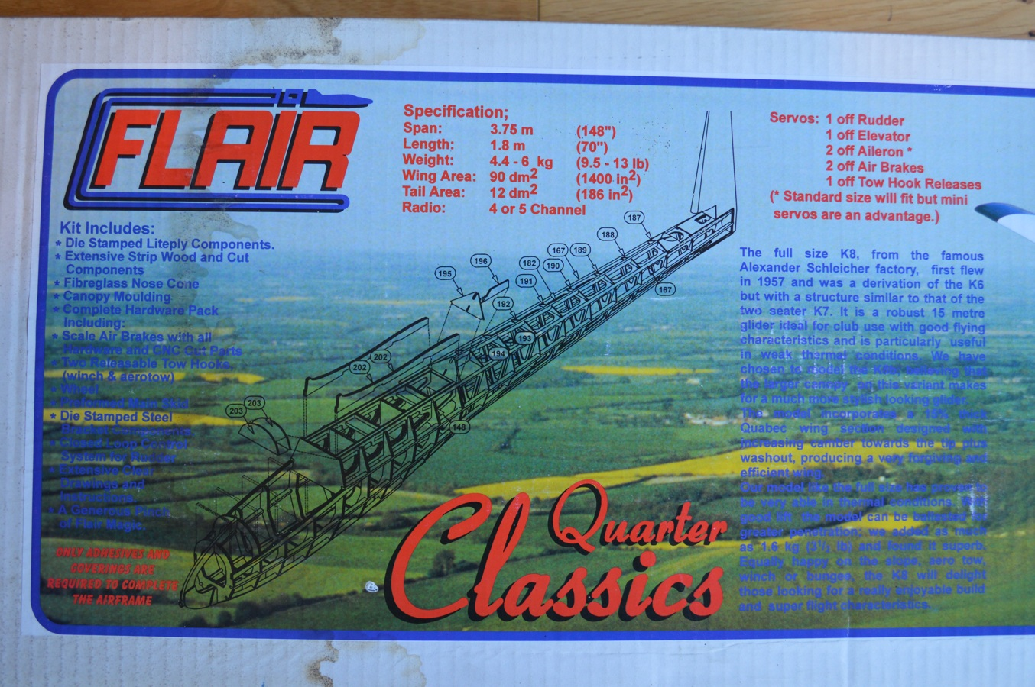

The full size K8, from the famous Alexander Schleicher factory, first flew in 1957 and was a derivation of the K6 but with a similar structure to that of the two seater K7. It is a robust 15 metre glider ideal for club use with good flying characteristics and is particularly useful in weak thermal conditions. We have chosen to model the K8b, believing that the larger canopy on this variant makes for a much more stylish looking glider.
The model incorporates a 15% thick Quabec wing section designed with increasing camber towards the tip plus washout, producing a very forgiving and efficient wing.
Our model like the full size has proven to be very able in thermal conditions. With good lift the model can be ballasted for greater penetration; we added as much as 1.6 kg (3 1/2lb) and found it superb.
Equally happy on the slope, aero tow, winch or bunges, the K8 will delight those looking for a really enjoyable build and super flight characteristics.

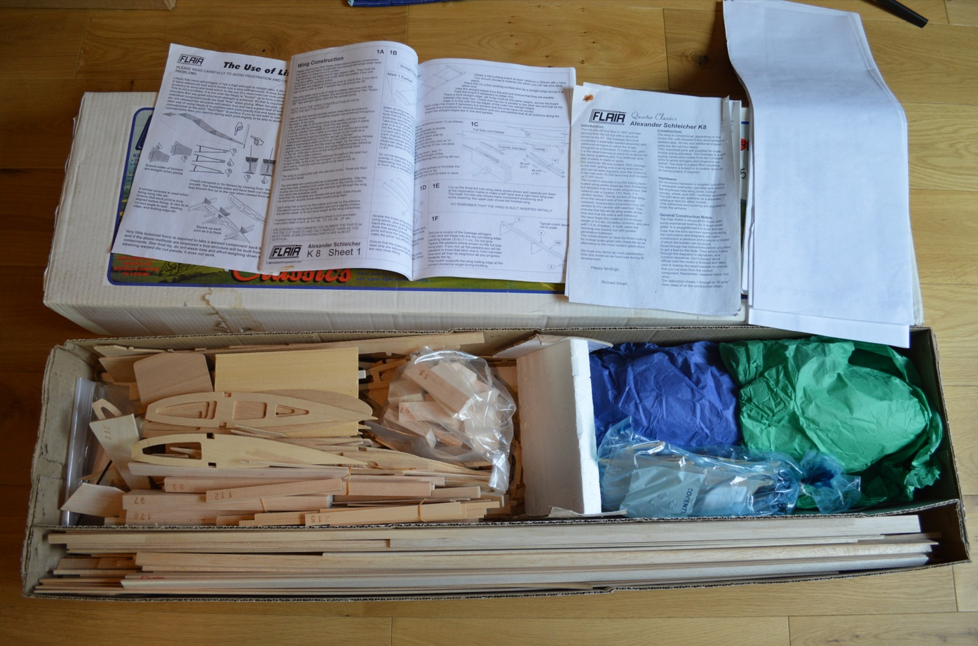

Kit contents:
- Die stamped Liteply components
- Extensive strip wood and cut components
- Fibreglass nose cone
- Canopy moulding
- Complete hardware pack including:
  - Scale air brakes with all hardware and CNC cut parts
  - Two releasable tow hooks (winch and aerotow)
  - Wheel
  - Preformed main skid
  - Die stamped steel bracket components
  - Closed loop control system for rudder
- Extensive drawings and instructions
- A generous pinch of Flair magic

New old stock kit from Flair. £250
dave_gresham@hotmail.com
07971 426432

Minimoa (167″)

MW2669 https://www.sarikhobbies.com/product/minimoa-167/

A slightly reduced version at 1:4 scale of the MW2665, to give the builder a choice of wingspans. However, the timeless elegance of this design is apparent at any size. Designed by Chris Williams.

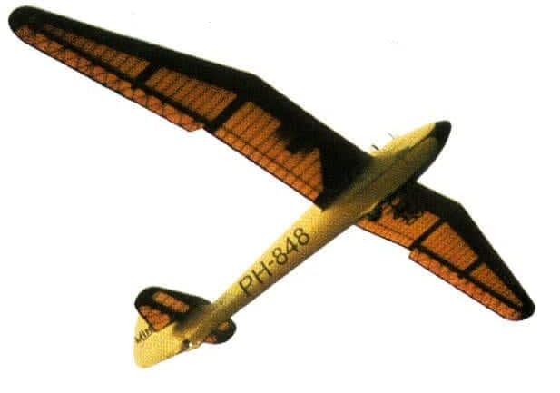
Specification
- Designer: Chris Williams
- Wingspan: 167″ / 4240 mm
- Radio Functions: 4
- Scale: 1:4

One of the best known sailplanes, using a Quabeck 3.5/12 wing section. Aimed at the more experienced builder, the Minimoa will be a very rewarding scale project.

Plan £25.50 MW2669
Laser Cut Wood Pack £215 WP2669

Plan and cut part Wood pack £120
dave_gresham@hotmail.com
07971 426432

HW-4 Flamingo (5m / 196.85″)

MW3463 https://www.sarikhobbies.com/product/hw-4-flamingo-5m/

The 5 m wingspan 1/3.5 Scale version of this Scale vintage sailplane replica from Chris Williams, HW-4 Flamingo is both elegant and a fine flyer whether aerotowed or launched from the slope.

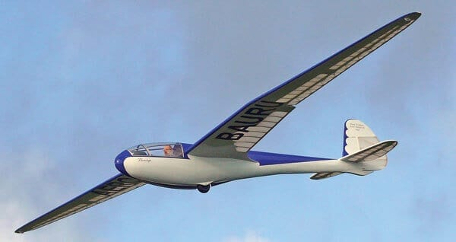

Specification
- Designer: Chris Williams
- Wingspan: 5 m / 196.85″
- Radio Functions: Rudder, elevator, ailerons, tow release
- Weight: 8.6 kg / 18.95 lb
- Scale: 1/3.5

HW-4 Flamingo 5 m (196.85″) Wingspan – MW3463 – World Class Designer Chris Williams turns to a Brazilian sailplane dating from 1947. The HW-4 Flamingo was a one-off sailplane built in Brazil in 1947 and described in Martin Simons’ book ‘Sailplanes 1945-1965’ as ‘elegant’, having a relatively high aspect ratio wing, coupled with a classic gull break. Chris Williams has been campaigning this larger 1/3.5 scale version for some years now, but after the success of the 1/5th scale Petrel (full short kit also available from Sarik Hobbies RC2207), a smaller 3.4m version is also available.
Just like the Petrel the fuselage is relatively heavy, being plywood-clad, whilst the wings are super-light. It’s this combination that allows these models to fly in just about any condition, regardless of wind speed.

Plan and article £33.50 MW3463
Canopy £28 CA3463CY
Laser Cut Wood Pack £250 WP3463

Plans and article, canopy and cut part wood pack. £140.
dave_gresham@hotmail.com
07971 426432

BKB-1 Sailplane (120″)

MW3570 https://www.sarikhobbies.com/product/bkb-1-sailplane-120/

A 120 in. span scale sailplane for 3-4 function R/C. Rescaled by Laddie Mikulasko.

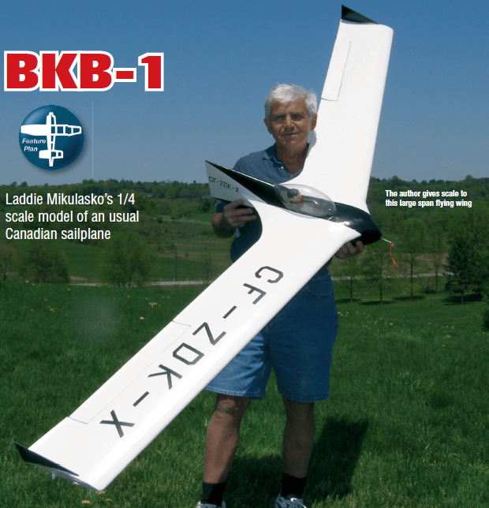

Specification
- Designer: Laddie Mikulasko
- Wingspan: 120″ / 3048 mm
- Power Source: IC Propeller
- Radio Functions: 3 – 4
- Scale: 1:4
- Weight: 8 lb 8 oz / 3855 g

This unusual-looking single-seat Canadian sailplane (flying wing) designed by Stefan Brochocki and rescaled to 1:4 by Laddie Mikulasko, spans 120 inches and features all wood construction, with a fibre-glassed finish to the fuselage. (Laser cut wood pack of ribs and formers is available.) The model uses elevons, with rudders on the wingtips doubling as speed brakes via Tx mixing. Flying weight approx. 3855 g. Not suitable for beginners.

Plan and article £23.50 MW3570
Laser Cut Wood Pack £159 WP3570

Plan and cut part wood packs £80

dave_gresham@hotmail.com
07971 426432

Fauvel AV48 (158.5″)

MW3392 https://www.sarikhobbies.com/product/fauvel-av48-2/

The full-size prototype never flew, but Vic Steel has produced this unusual flying wing motor glider to 1:4 scale, and it does fly… very well.



Specification
- Designer: Vic Steel
- Wingspan: 158.5″ / 4 m
- Power Source: Vortex 50/55/730 (730 rpm/V) + 6s LiPo
- Radio Functions: 3 – 4
- Scale: 1:4

Construction is all wood with a fibreglass skin. Your choice of motor or glider version. Not for beginners.

Plan and article £35.50 MW3392
Laser Cut Wood Pack £216 WP3392
Canopy £28 CA3392CY

Build inst, plan, canopy, cut part wood packs £130

dave_gresham@hotmail.com
07971 426432

Red Eagle Glider Kit (79”)

https://www.rbckits.com/shop/red-eagle-glider-complete-kit.html

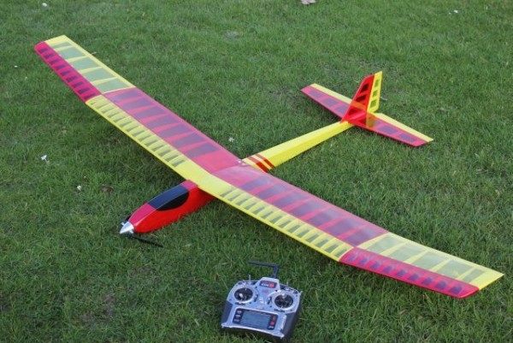

As A Complete kit [£100 from RBC]
Wingspan : 79” 2000mm
Weight: 850gr
Power 2830-1000kv
Prop :10x6
Batt: 3s2200

Plan, cut parts, stringers, sheet, some hardware. USB with build inst and pics £50

dave_gresham@hotmail.com
07971 426432

EoN Olympia 2B

148" (3750mm) span. Full size design by Hans Jacobs in 1939. This 1/4 scale glider designed for modelling by Cliff Charlesworth.



Description
The Eon Olympia 2b
This glider was produced from 1947 by Elliotts of Newbury.
Elliotts had been asked in 1945 by Chilton Aircraft Ltd to make one set of wings for the Chilton Olympia, a glider that had been developed in pre-war Germany as the
DFS Olympia Meise.
This had been designed by Hans Jacobs and selected as the glider for the 1940 Summer Olympics. The German drawings were not detailed and so entirely new drawings were made by Chilton that merely retained the Meise Olympia’s aerodynamic shape. Otherwise it was a complete re-design and resulted in a stronger and heavier (+30 kg) aircraft. To maintain employment at their factory, Elliotts refused to sell the wing jigs that they had made for the prototype. Consequently, Chilton gave up all aircraft work, agreeing to sell to Elliotts the production rights, fuselage jigs, and work in hand on all Olympia gliders.
Production of the Olympia (originally called Type 5) started in 1946 as a batch of 100, and the first flight was made in January 1947. Elliotts and their design consultants Aviation & Engineering Products Ltd made improvements to the original design before starting production. Marks 1, 2 and 3 were produced, mainly distinguishable by the landing gear. The Mark 1 had only a skid whereas the Olympia 2 had a built-in main wheel. The Eon Olympia 3’s wheel was jettisonable after take off. The first batch of 100 was completed in 1947 but the market could not absorb such a large number, despite the low price of £425. Even by 1953, 40 of the first 100 Olympias were still unsold. Nevertheless, a second batch of 50 was built. Gliders from the second batch were still being offered for sale for £800 as late as 1957 in order to clear the stock, despite being below cost price.
After building three marks of the Olympia, another improved version, called the EoN Olympia 4 was produced in 1954. This is regarded as being sufficiently different from the original as being a new type. This type in turn led to a succession of variants.

Belair cut part kit: Plans, cut parts and canopy £100.
dave_gresham@hotmail.com
07971 426432

Scheibe Bergfalke II/55 (156″) 3960mm

MW3084 https://www.sarikhobbies.com/product/scheibe-bergfalke-ii-55/

This almost 1:4 scale vintage design by the accomplished Chris Williams has been redesigned from an original drawing to be lighter and more efficient.
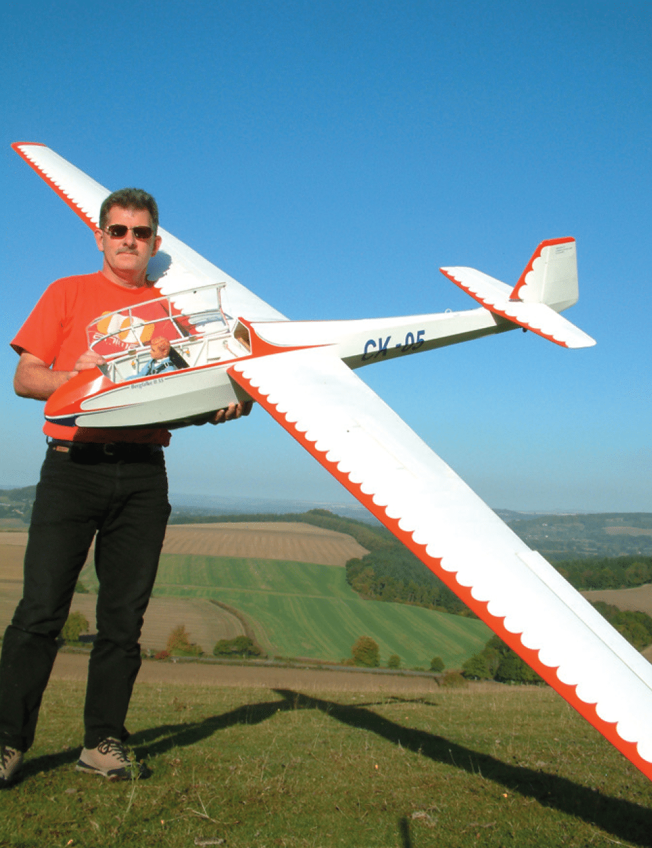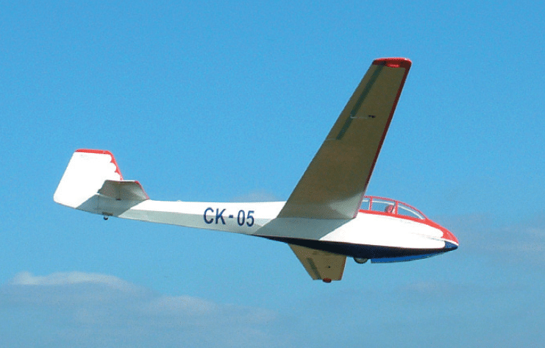

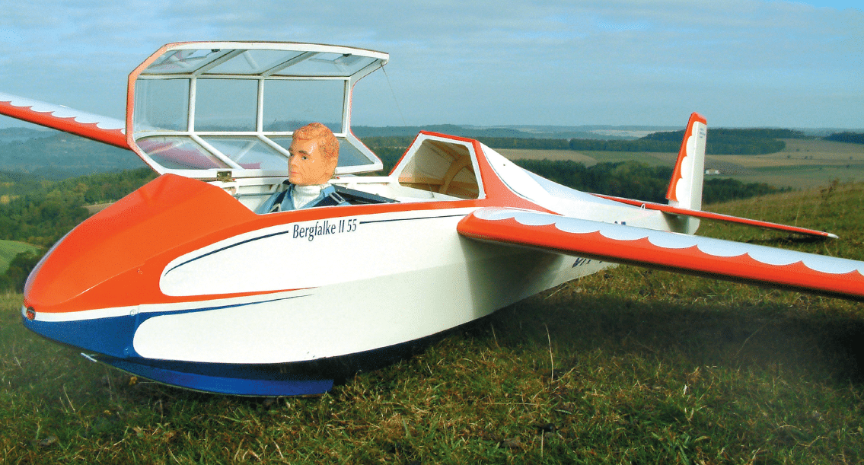

Specification
- Designer: Chris Williams
- Wingspan: 156″ / 3960 mm
- Radio: 4 function
- Length: 73.5″ / 1867 mm
Plan and Belair cut part wood pack £100
dave_gresham@hotmail.com
07971 426432

Alexander Schleicher ASK-13

1/4 scale 148" span by Cliff Charlesworth.

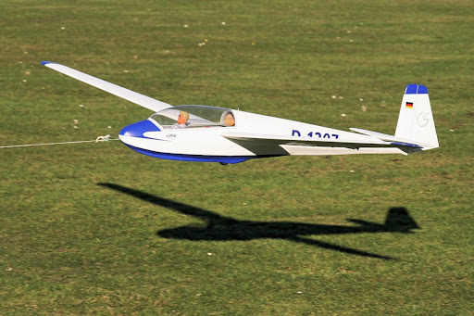

Belair cut part wood pack, plan and canopy. £100

dave_gresham@hotmail.com
07971 426432

Schleicher ASK-11 (126″)

MW3657 https://www.sarikhobbies.com/product/schleicher-ask-11-126/

A 126″ scale motor-glider for 5-function R/C. Rescaled by Chris Williams for 5-function R/C.



Specification
- Designer: Chris Williams
- Wingspan: 126″ / 3.21 m
- Wing section: HQ35/14 @ Root; HQ35/12 @ Tip
- Power Source: E-Power BL4030 385 KV Brushless Outrunner
- Radio Functions: 5 (ailerons, elevator, rudder, throttle, air-brakes)
- Scale: 1:4
- Battery: 2200 mAh or 3300 55C 5S LiPo
- Weight: 8-9 lb (3.6-4 kg)
- Prop: 13″ x 11″ folding
- ESC: 60A Optoflight

The Schleicher ASK-11 is an unusual model to scale, but Chris Williams has managed this at 1:4 scale on the 2 well-detailed large CAD plans that enable it to be flown with a BL4030 385KV outrunner with a 2200-3300 mAh 5s LiPo. Construction is all wood and a laser cut wood pack is also available, plus a moulded canopy. Not for beginners.

Plan and article £25.50 MW3657
Laser cur wood pack £175 WP3657

Mags with build article, Plans, cut part wood pack £100
dave_gresham@hotmail.com
07971 426432
Stella Clipper (62″)
MW3798 https://www.sarikhobbies.com/product/stella-clipper-62/

A 62” span ‘Hotliner’ glider for 4 function R/C and a 480Kv outrunner motor. Designed by Brian Austin.

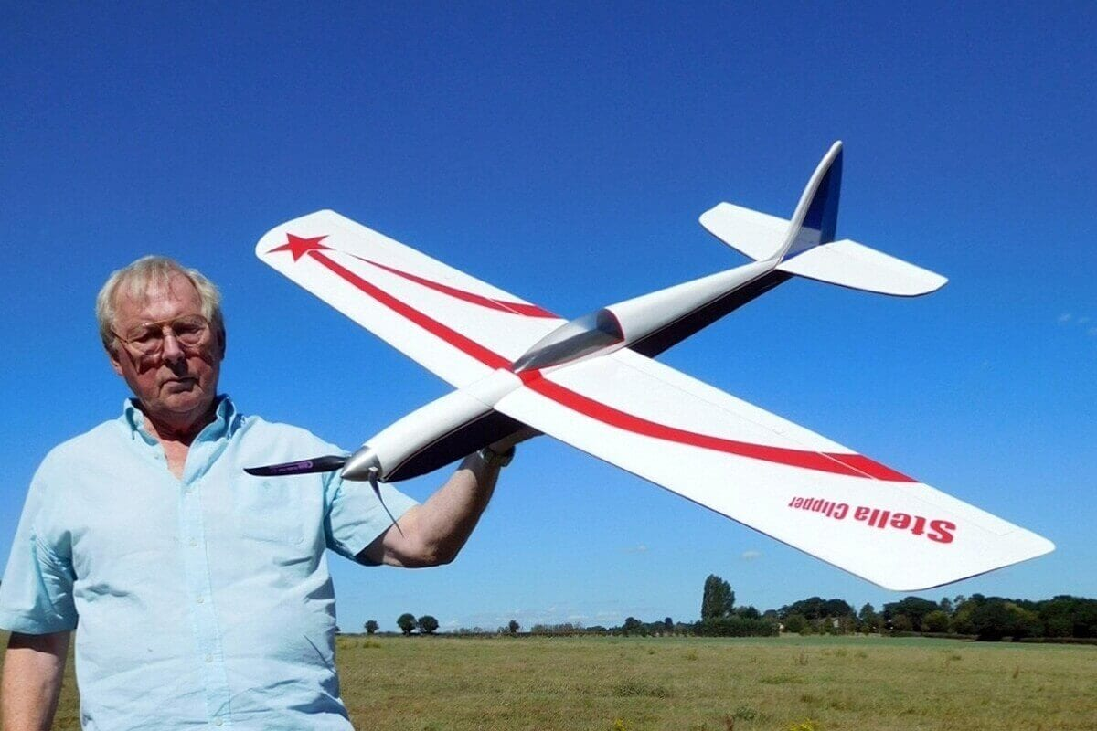

Specification
- Designer: Brian Austin
- Wingspan: 62″
- The powertrain fitted on the prototype is Turnigy SK3 Comp Series 3858-4.6 840KV brushless outrunner with an 80 Amp ESC turning a 13″ x 8″ or 14″ x 9″ APC-E prop powered by a 3S 2650-5000mAh LiPo
- Radio: 4-function R/C and suits, intermediate pilots
- Flying weight around: 1540 g.

This is a sporty 1575mm span ‘hotliner’ glider design from Brian Austin with a sparkling performance constructed from all wood from the large detailed CAD plans. The powertrain fitted on the prototype is Turnigy SK3 Comp Series 3858-4.6 840KV brushless outrunner with an 80 Amp ESC turning a 13″ x 8″ or 14″ x 9″ APC-E prop powered by a 3S 2650-5000mAh LiPo. Uses 4-function R/C and suits, intermediate pilots. Flying weight around 1540 g

Plan and article £17.50 MW3798
Laser Cut Wood Pack £53 WP3798

Plan and article, Wood pack plus new old stock in box Turnigy Gliderdrive SK3 4.6 840kv motor and Turnigy 80A ESC £100

dave_gresham@hotmail.com
07971 426432
Fournier RF5 kit (70” span approx.)

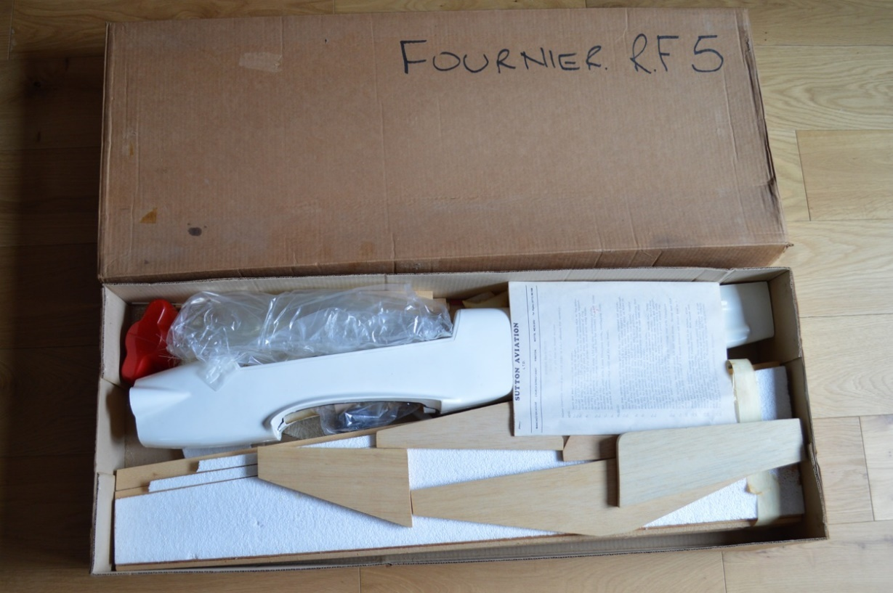

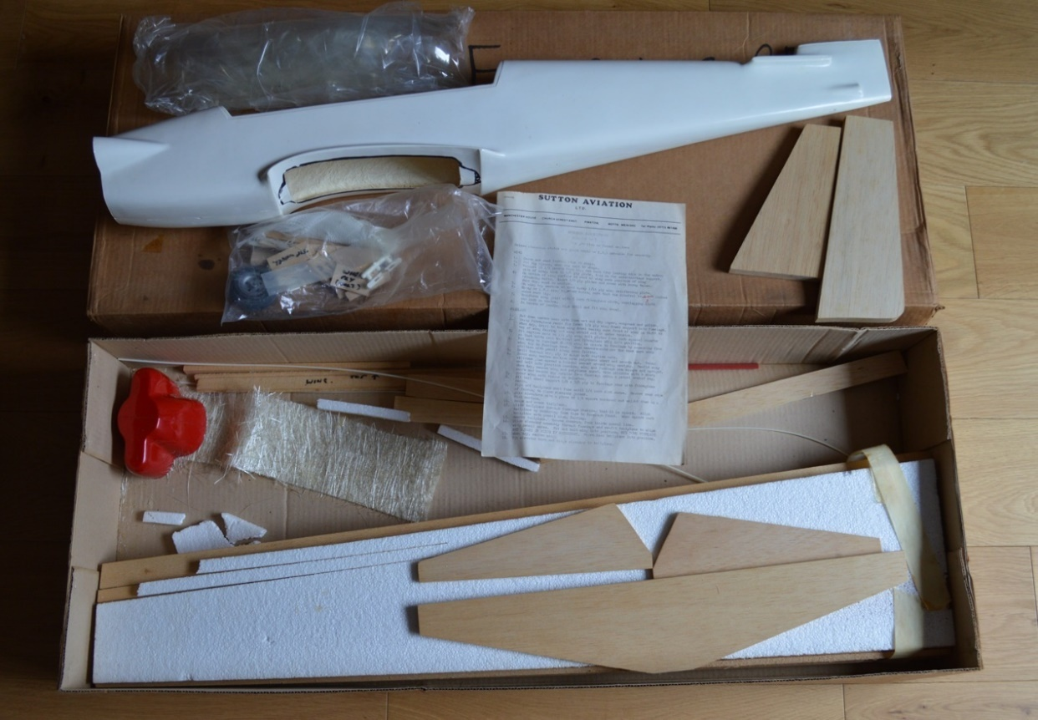

Motor glider, Fibreglass fuselage and ply covered foam wings (that exposed foam is just the packing material)

Kit as seen £50
dave_gresham@hotmail.com
07971 426432

Lapwing 60 (61″)

MW3418 https://www.sarikhobbies.com/product/lapwing-60-2/

A 61” span tailless slope-soarer for 2-function R/C. Designed by Andy Reid.

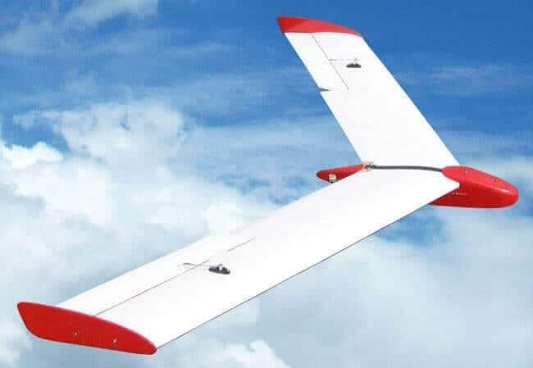

Specification
- Designer: Andy Reid
- Type: Classic 30 deg sweep tailless slope soarer
- Wingspan: 1550 mm (61″)
- Radio Functions: 2
- Weight: 26 – 28.5 oz/725 – 800 g

The 61” span classic 30-degree swept wing tailless slope-soarer designed by Andy Reid is an easy build from all wood and uses elevator/aileron (elevon) control mixing with mini servos, all shown on the detailed single sheet plan.

Plan and article £16.50 MW3418
Laser Cut Wood Pack £54 WP3418

Plan and cut part wood pack £30

dave_gresham@hotmail.com
07971 426432

Watts Up (100″)
MW3398 https://www.sarikhobbies.com/product/watts-up/
This successful 100-inch Class competition/sport glider makes a great electric thermal searcher for the sports flyer.
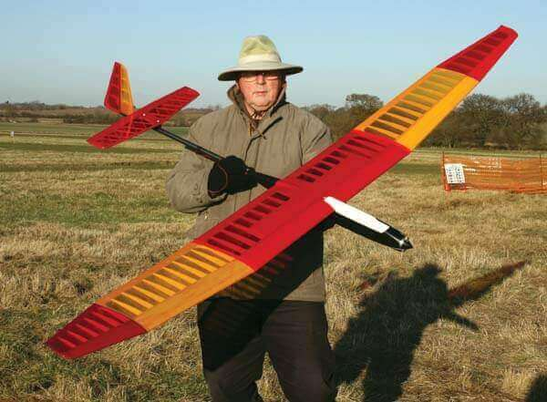
Specification
- Designer: Brian Austin & Ray Pavely
- Wingspan: 100″ / 2.54 m
- Power Source: Mega 22/20/3E
- Length: 53″ / 1350 mm
- Wing Section: MH32
- Motor: Mega 22/20/3E
- Radio Functions: 4
This successful 100-inch Class competition/sport glider designed by Brian Austin and Ray Pavely uses the MH32 wing section and is ideal for those who like the idea of optional extendable wing panels and makes a great electric thermal searcher for the sports flyer.
Construction is mainly wood with some carbon parts (Carbon NOT included) shown on the large single-sheet plan.
Plan & Article £20.50 MW3398
Laser Cut Wood Pack £119 WP3398

Plan, article and cut part wood pack only £60
dave_gresham@hotmail.com
07971 426432

Howzat II (98″)

RC2191 https://www.sarikhobbies.com/product/howzat-ii-90/

Chris Williams updates his retro style aerobatic slope soarer with few of the latest modern touches. This aerobatic slope soarer has a look and feel of realism, with equally pleasing performance.


Specification
Wingspan: 98″ (2.5 m)
Wing Area: 5.6 sq ft (52 sq dm)
Wing Loading: 15 oz/sq ft
Length: 52″ (1.33 m)
Weight: 5 lb (2.26 kg)
Radio Functions: 4
Basic Construction Materials: Balsa, Ply, Liteply

First published in RC Model World over 30 years ago as plan MW2051, Howzat is a smooth aerobatic slope soarer. Designer, Chris Williams has now revisited this elegant 98″ wingspan glider for the May 2018 issue of RCM&E, to add a few modern touches such as separate aileron servos and an All Moving Tailplane, plus a Ritz 2 wing section.
Plan £17.50 RC2191
Laser Cut Wood Pack £84 WPRC2191

Plan and cut part wood pack only £50
dave_gresham@hotmail.com
07971 426432
Fieldfare (72″)

MW3511 https://www.sarikhobbies.com/product/fieldfare-72/

A 72-inch span high-performance electric soarer for 140W brushless motors and 3-function R/C. Designed by Sid King. Suitable for beginners.

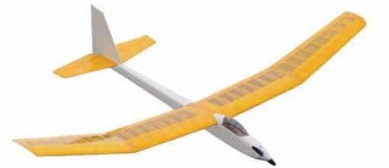

Specification
- Designer: Sid King
- Wingspan: 72″ / 1830 mm
- Power Source: A2212-10T 1400 rpm/V (140 Watt) or similar 20A ESC
- Radio Functions: 3
- Battery: 2200mA 2s LiPo

Sid King is renowned for his quality model designs and this easy to build 3-function electric glider is no exception.
Its 72-inch span and brushless 140 Watt motor with a 2S 2200mA LiPo for power will give you relaxing summer-evening flying. Construction is from two well-detailed plan sheets. Suitable for beginners.

Plan £15.50 MW3511
Canopy £15.00 CA3511CY

Plan and canopy only £20

dave_gresham@hotmail.com
07971426432

SZD Zefir (140″)

MW2013 https://www.sarikhobbies.com/product/szd-zefir-2/

Designed by Keith Humber as a true 1:5 scale model, this superb flying machine will soar from light winds to heavy.

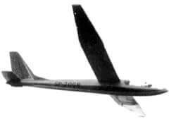

Specification
- Designer: Keith Humber
- Wingspan: 140″ / 3550 mm
- Radio Functions: 4
- Scale: 1:5

Plan £25 MW2013
Canopy £15 CA2013CY

Plan and canopy only £20

dave_gresham@hotmail.com
07971 426432

Scheibe Bergfalke IV (173″)

MW3750 https://www.sarikhobbies.com/product/scheibe-bergfalke-iv-173/

A 1/4 scale version of the last variant in the Scheibe Bergfalke range. Designed to excel in light conditions on the slope, she is equally at home in stronger winds or on aerotow

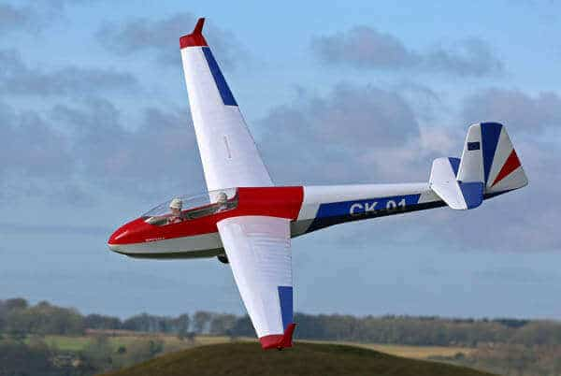

Specification
- Designer: Chris Williams
- Wingspan: 4.4 m (173.2283″)
- Radio Functions: Spoilers, Ailerons, Elevator, Rudder, Tow release
- Scale: 1/4
- Length: 2.2 m (86.61417″)
- Weight: 13 lb (5.8 kg)

Plan £37.50 MW3750
Canopy £28 CA3750CY

Plan and build article only £20

dave_gresham@hotmail.com
07971 426432

Apollo 91”

MAG1548 https://www.sarikhobbies.com/product/mag1548-apollo-plan/

91" span electric powered glider by Pete Kessell.

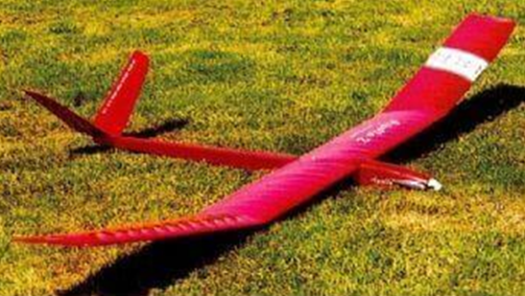

Name: Apollo
Model Type: Electric-Powered Glider
Designed By: Pete Kessell
Wingspan: 91" (2310mm)
Wing Section: SD3021 (modified)
Wing Area: 4.9sq. ft. (0.45sq.m)
Wing Loading: 7-8oz/sq.ft.(2.1-2.4kg/sq.m.)
Fuselage Length:43" (1092mm)
All-Up Weight: 2.2-2.4lb (1.1.1kg)
Rec'd Motor: Permax 600 7.2V
Battery: 7XCP1200
ESC: Jeti 35A
Propeller: Graupner 9X5" Propeller set no. 1335.23.12
Control Functions: Rudder, Elevator, Throttle

Plan and mag with build article and decals. £20

dave_gresham@hotmail.com
07971 426432

‎Fournier RF4 (88″)

RC1541 https://www.sarikhobbies.com/product/fournier-rf4-88/

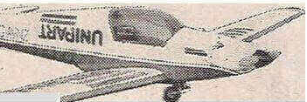

Designer: Bill Burkinshaw Star Rating: *** Wingspan: 2235mm Engine Size: 0.40 R/C Functions: 4 True scale outlines and possibilities for a range of bright colour schemes make this 88in. span aerobatic model for 0.35-0.40 cu.in. 4 strokes an attractive model. Up to 6 function RlC, to include retract and spoilers, can be used.

[from Sarik plan £19, cowl, canopy, tail fairing £15]

Plan, cowl, canopy, tail fairing, mag build article, templates for ribs and formers £30

dave_gresham@hotmail.com
07971 426432

Fournier RF5B “Sperber” (169.5″)

MW3693 https://www.sarikhobbies.com/product/fournier-rf-5b-sperber-plan/

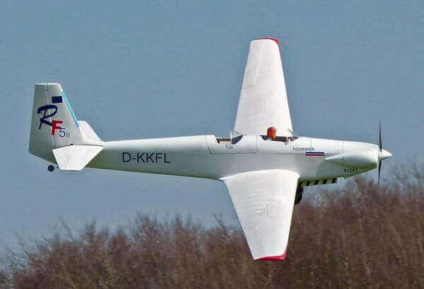

Specification
- Wingspan: 4.3m / 169.5″
- Wing Section: HQ35/14-12
- Weight: 17 lb. / 7.7 kg
- Scale: 1:4
- Radio Functions: 5

Chris Williams has rescaled and modelled this tandem cabrio motor-glider to 1:4 scale on 3 very large, well-detailed CAD-drawn plan sheets for 5-function R/C and a BL4030 outrunner. With a model weight of just 7.7 kg it is a delight to fly.[from Sarik Hobbies £33.50 for plan and article]

Plan only £15

dave_gresham@hotmail.com
07971 426432

Pteranodon 2235mm (88") span flying Dinosaur.

RC1583 https://www.sarikhobbies.com/product/rc1583-pteranodon/

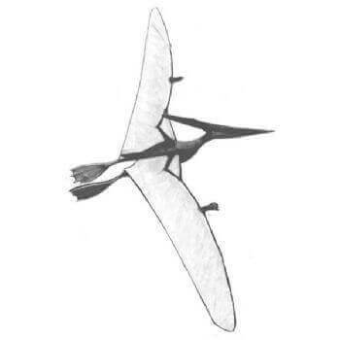

Designed by Stephen Winkworth who designed a series of R/C models of the prehistoric Pteranodons for television filming and this is his practical four function Pteranodon IV with an 88in wingspan. [from Sarik £18.50 for plan only]

Plan, magazine with build and fibreglass head £20.

dave_gresham@hotmail.com
07971 426432

BJ-1 Duster 102"
MW3648 https://www.sarikhobbies.com/product/bj-1-duster-1-5th/
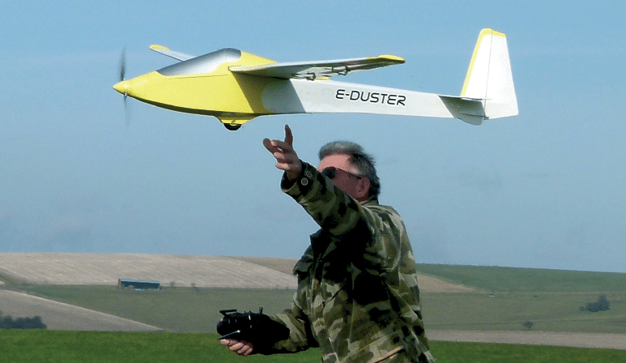
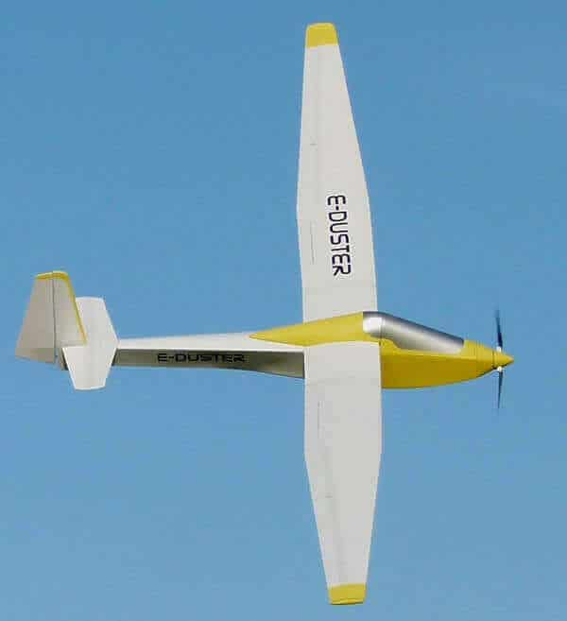 [from Sarik £19.50 for plan and article]
Specification
- Designer: Chris Williams
- Scale: 1:5
- Wingspan: 102″ / 2.6m
- Power Source: E-Power 2810 1100 KV brushless
- Wing Selection: HQ35/12 (no washout)
- Weight: 4 lb / 1.8 kg
- Motive Power: 60A brushless
- ESC 3S 2200 mAh LiPo
- Radio Functions: 5
Designer Chris Williams has enlarged his 1:6 scale model to this 1:5 scale 102” span scale glider and included electric power for ease of flying from a flat field. Can also be aerotowed or flown from a slope. Traditional construction methods from a single, very large and well-detailed plan sheet. Performance is ideal with a budget 2810/1100KV brushless motor with 3S 2200 mAh Lipo for power.

Plans and magazine build £10
dave_gresham@hotmail.com
07971 426432

ZY-400

MW2227 https://www.sarikhobbies.com/product/zy-400/

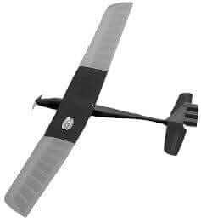

Specification
- Designer: Nigel Bathe
- Wingspan: 60″ / 1525 mm
- Power Source: Speed 400 & 7-cell pack
- Radio: 3 function
- Motor: Speed 400 & 7-cell pack

Designed by Nigel Bathe. An elegant all balsa construction electric glider, for Electroslot 400 contests or pleasurable duration flying.

Plan and build article £10

dave_gresham@hotmail.com
07971 426432

Power Rookie 76"

MF49.

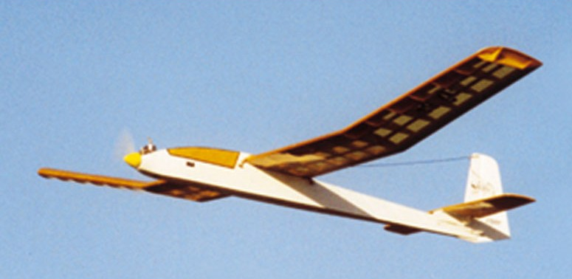

Design by David Boddington.

Plan and magazine with build article only £10

dave_gresham@hotmail.com
07971 426432

