Balsa USA 1/4 Scale J-3 Piper Cub (108”)
BUSA438 https://balsausa.com/collections/1-4-scale-kits/products/1-4-scale-j-3-piper-cub
£410 from Leeds model shop
61 to .90 two stroke or 0.90 to 1.20 four stroke
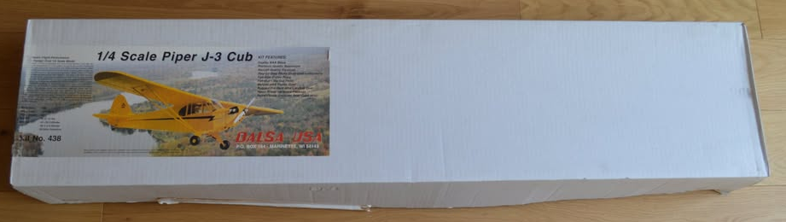
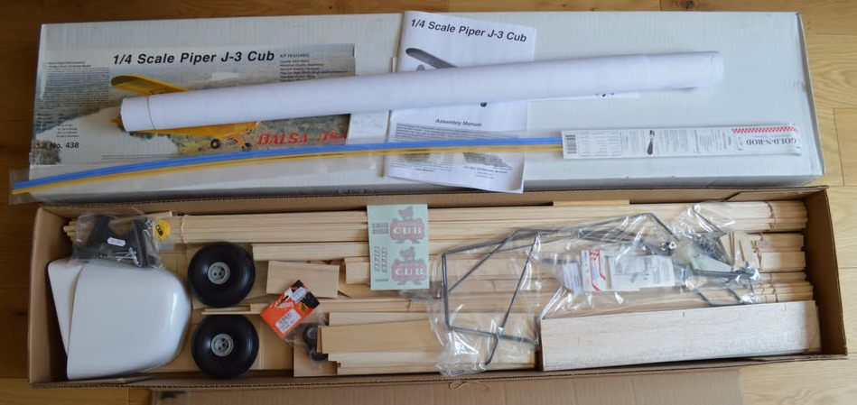

New old stock kit plus one-piece cowl, wheels, rods £280
dave_gresham@hotmail.com
07971 426432
Balsa USA Fokker E111 Eindecker 90 (80”)
BUSA417 https://balsausa.com/products/fokker-eiii-eindecker-90
£325 from Leeds model shop not including gun or wheels
.46 to .60 two stroke or 0.61 to .91 four stroke
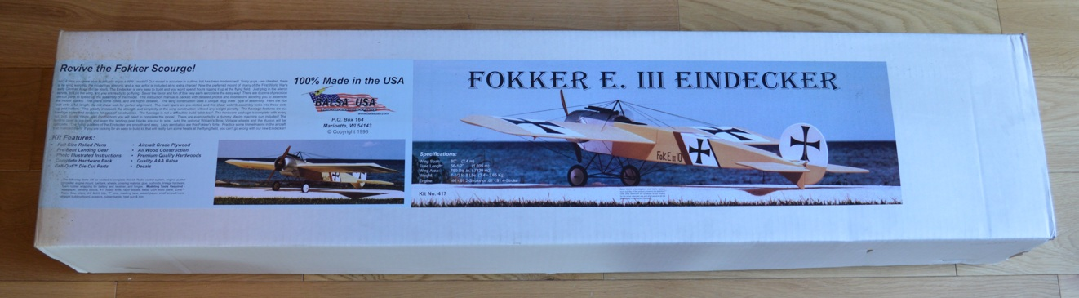
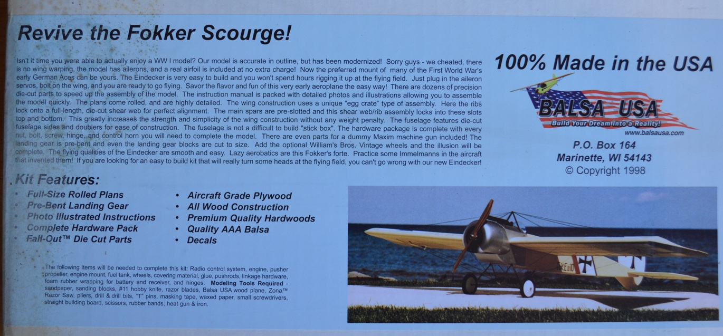
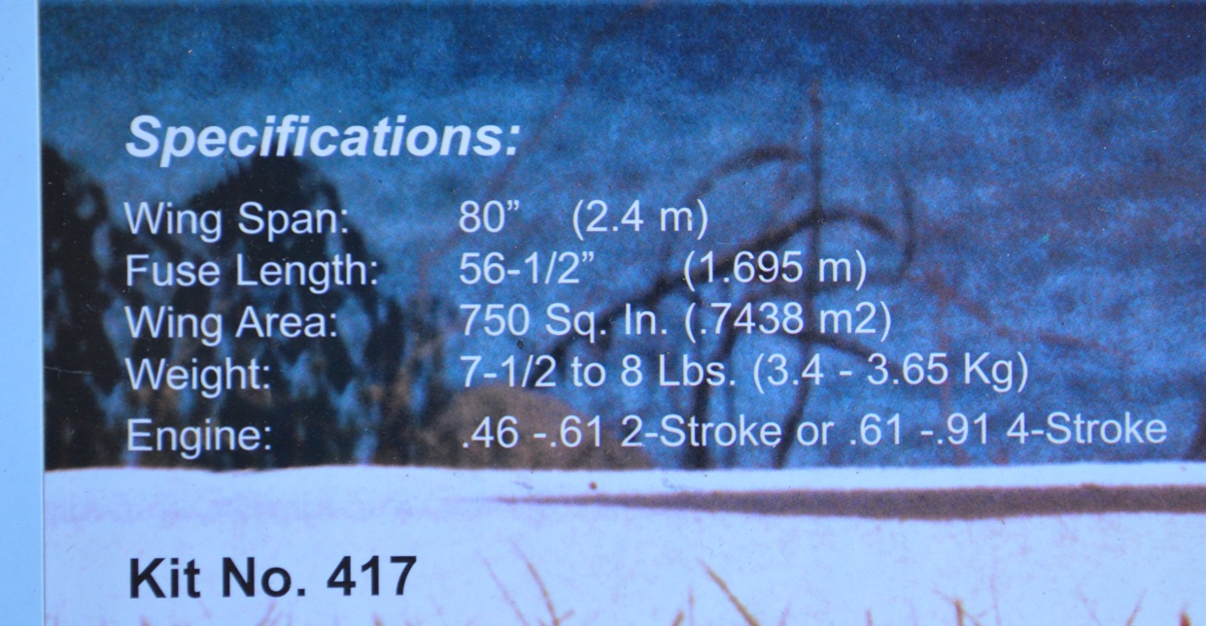
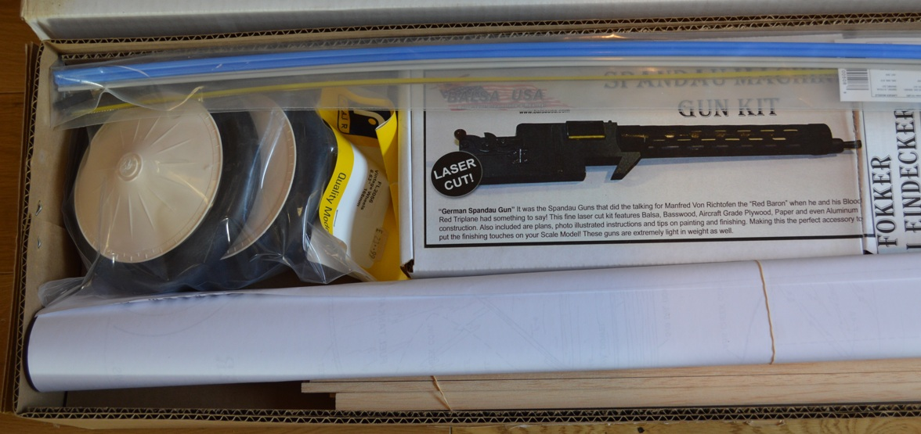
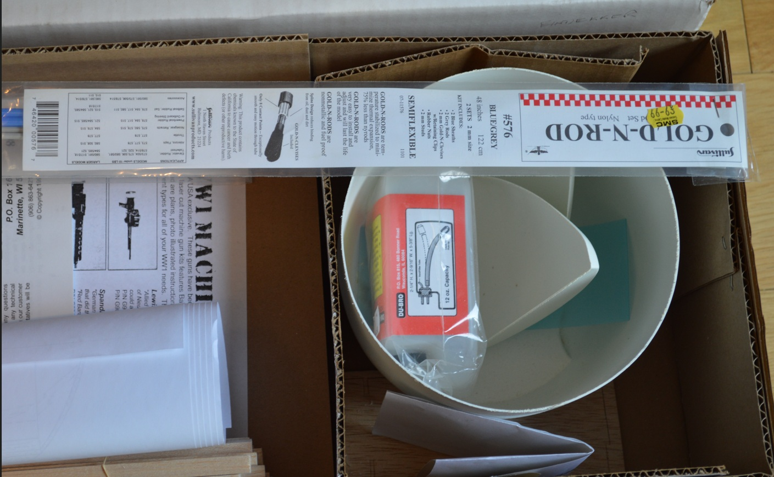

New old stock kit, plus wheels, tank, rods £220
dave_gresham@hotmail.com
07971 426432

Balsa USA Etrich Taube 90 (83”)
BUSA394 https://balsausa.com/products/1913-etrich-taube-90
£325 from Leeds model shop
.60 to .80 two stroke or 0.70 to .91 four stroke
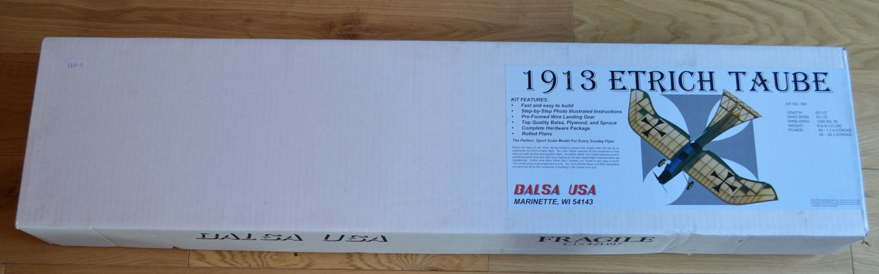
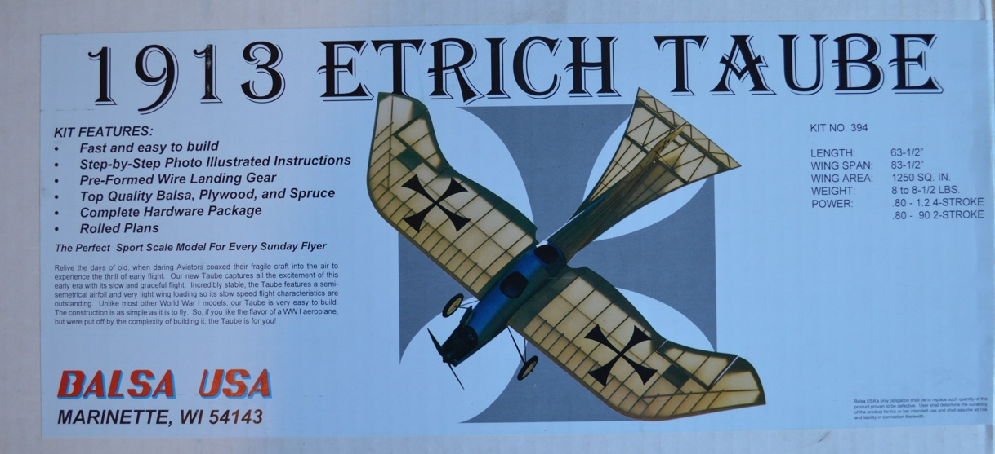
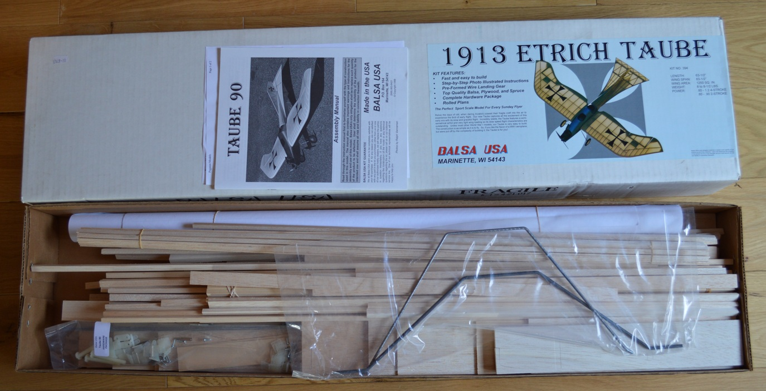
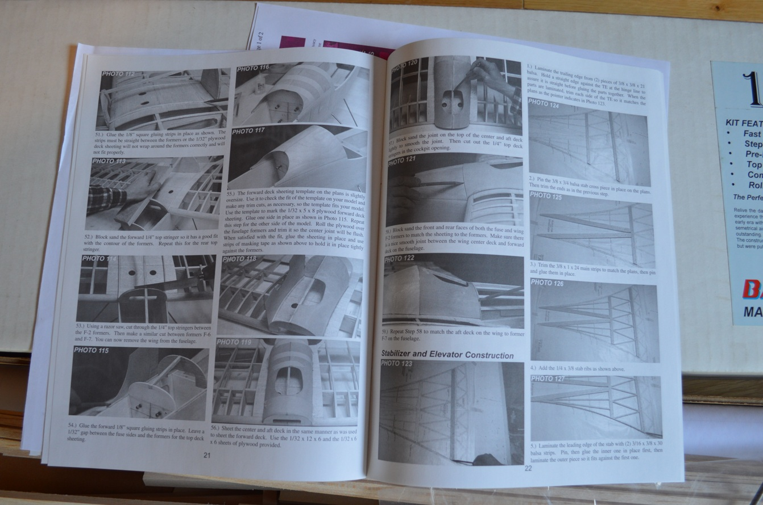

New old stock kit, £200
dave_gresham@hotmail.com
07971 426432

Hawker Typhoon 1B (72.75”)
MW3339 https://www.sarikhobbies.com/product/hawker-typhoon-mk-ib-72/
1:6.86 scale, 1,848 mm (72.75”) wingspan model of the classic British fighter, presented on a two sheet plan and features a retracting undercarriage and working flaps.
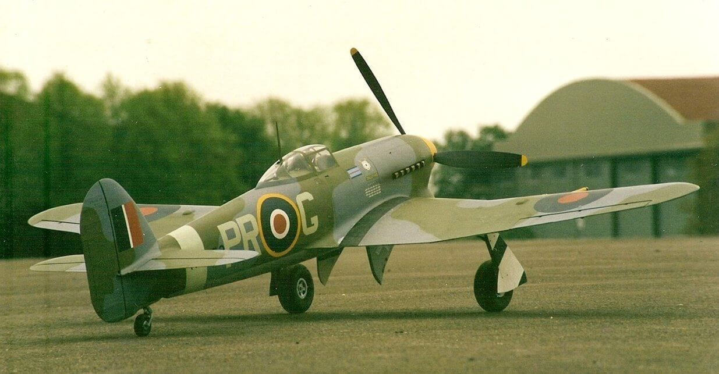
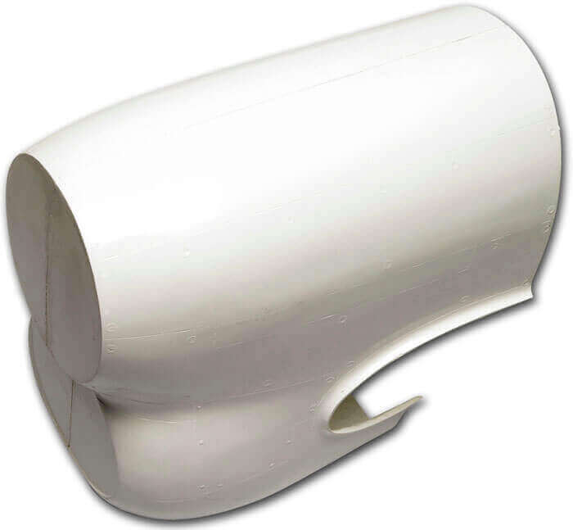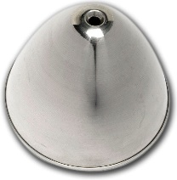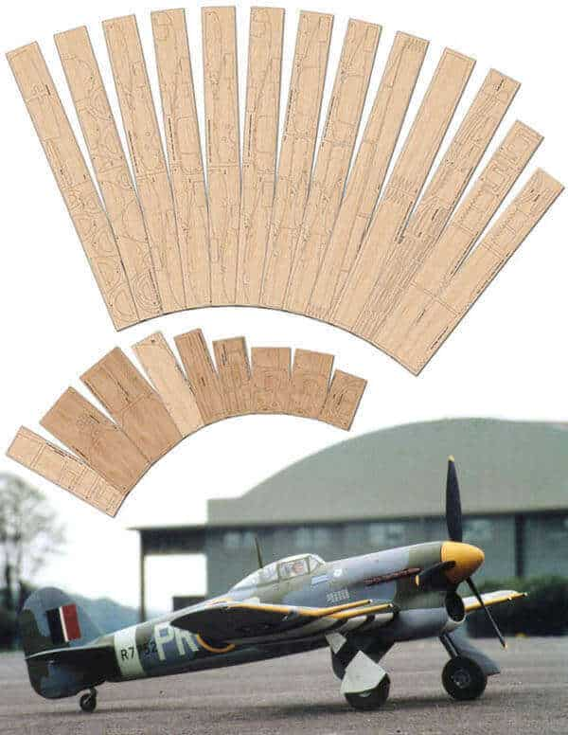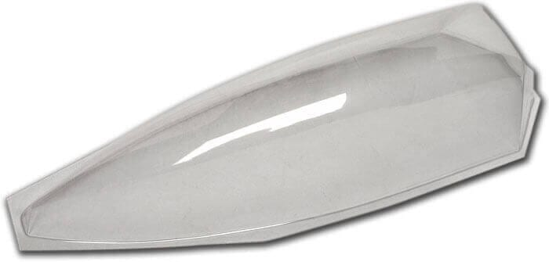
Specification
- Designer: Brian Taylor
- Wingspan: 72.75″ / 1848 mm
- Power Source: .90 to 1.20 cu. in. 4-stroke
- Radio Functions: 6
- Scale: 1:6.86
The Full Size: The Hawker Typhoon, known as the ‘Tiffy’, was a British single-seat fighter bomber, produced by Hawker Aircraft. It was intended to be a medium-high altitude interceptor, as a replacement for the Hawker Hurricane but several design problems were encountered and it never completely satisfied this requirement. When the formidable Focke Wulf Fw 190 entered the theatre of war in 1941 the Typhoon was the only RAF fighter capable of catching it at low altitudes. As a result, it secured a new role as a low-altitude interceptor. The Typhoon became established in roles such as a night-time intruder and long-range fighter. It also became one of WWII’s most successful ground-attack aircraft. Introduced at the end of WWII, this classic British fighter plan design by Brian Taylor features retracting undercarriage and working flaps shown on the 2 large detailed plans for all wood construction. Not for beginners.
Plan £29.50, Cowl £45, canopy £15, Ali spinner £29, cut part woodpack £179
Plan, cut part woodpack, cowl, canopy, spinner £150
dave_gresham@hotmail.com
07971 426432
Fiesler Storch Fi156 (93”)

MW3466 https://www.sarikhobbies.com/product/fieseler-fi-156-storch-93-2/

This is the larger1/6 scale version of this famous WWII German STOL reconnaissance aircraft from the Dennis Bryant Elite Plans range. Plans are 4 large well-detailed sheets, and construction is all wood. Plan also shows adjustable flaps and fixed slats. Weight approx 5 kg. Not for beginners.

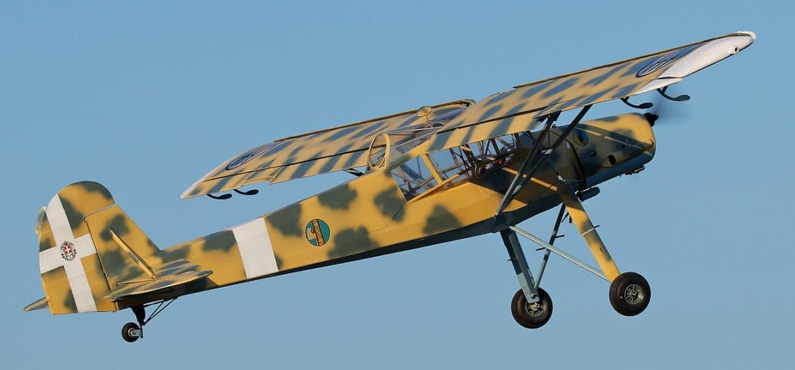
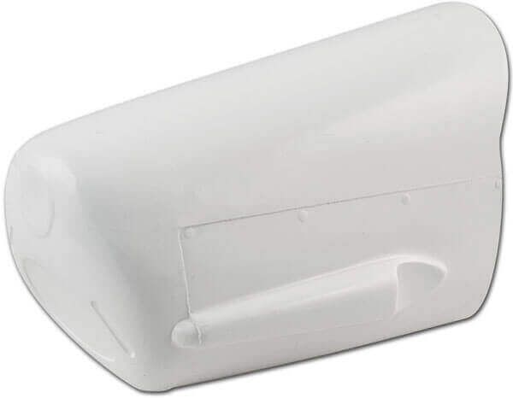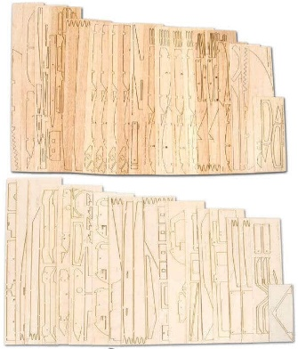
Specification
- Designer: Dennis Bryant
- Wingspan: 93″ / 2362 mm
- Power Source: .60 4-stroke; .90 4-stroke
- Power Source: IC Propeller
- Radio Functions: 5
- Scale: 1:6
- Weight: 5 kg / 11.02 lb

Plan £33.50, Cowl £37.50, cut part woodpack £172

Plan, cut part woodpack, cowl £120
dave_gresham@hotmail.com
07971 426432

Hawker Hunter (68”)
MW3603 https://www.sarikhobbies.com/product/hawker-hunter-68/

A 68” span scale Hawker Hunter model for EDF power and 6 functions R/C.

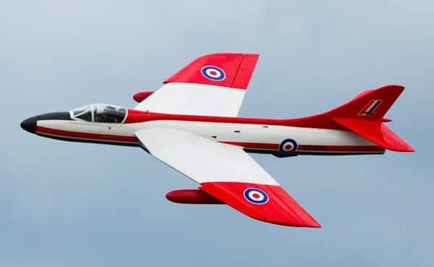
Specification
- Designer: Shane Harding
- Wingspan: 68″ / 1,727.2 mm
- Power Source: 110MM DUCTED FAN
- Radio Functions: 7
- Scale: 1:6
- Length: 93″ / 2,362.2 mm
- Weight: 16 lb / 7.25 kg

A well-detailed plan consisting of 3 sheets. Built of Balsa and Ply the model is constructed into a lightweight model that can be broken down for ease of transport. Designed primarily for a 12S-powered 110 mm fan unit. This should be a very cost-effective way to obtain an impressive-sized Jet model. Designer: Shane Harding
The Hawker Hunter is a subsonic British jet aircraft developed in the 1950s. The single-seat Hunter entered service as a manoeuvrable fighter aircraft and later operated in fighter-bomber and reconnaissance roles in numerous conflicts. Two-seat variants remained in use for training and secondary roles with the Royal Air Force (RAF) and Royal Navy until the early 1990s. The Hunter was also widely exported, serving with 21 other air forces.

Plan £33.50, cut part woodpack £278, full air retract kit with brakes £700

Plans and magazine with build, cut part woodpack, full air retract kit with brakes £500
dave_gresham@hotmail.com
07971 426432

Farm Hand (90”) 2286mm
MW3415 https://www.sarikhobbies.com/product/farmhand-90-2/

The 90” span version of this slot-together sports design for 4+ R/C functions and 30 to 65 cc petrol power is designed by Steve Holland.

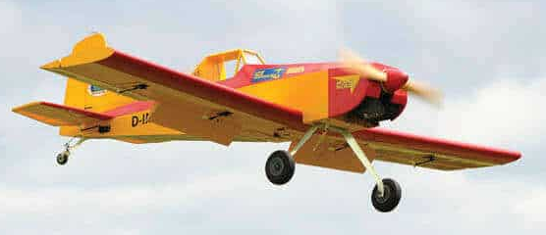

Specification
- Designer: Steve Holland
- Wingspan: 90″
- Radio Functions: 4+
- Motor: 30 to 65 cc petrol power

Designed by Steve Holland, Farmhand is suitable as a first large model project. It features balsa and ply construction with tabbed slot-together parts. It is aerobatic and can be adapted for aerotowing and toffee-bombing and features large flaps and a wide undercarriage track for excellent ground handling.

SET3415 – Illustrated sheet and construction guide, laser cutwood pack £178

Illustrated sheet & construct guide, cut part wood pack £100
dave_gresham@hotmail.com
07971 426432

Flair DH82A Tiger Moth (89”)
FL1047

Specification:-
Wingspan: 2260mm
Weight: 7.3~9kg
Length: 1840mm
Engine: .90~1.50 2 stroke or 1.20~1.80 4 stroke
Radio: 4 ch, 5 servos
Complete kit but water damaged box £200
dave_gresham@hotmail.com
07971 426432

BAE Hawk (50”)
EDF design from https://www.tonynijhuisdesigns.co.uk/HawkEDF50inch.html
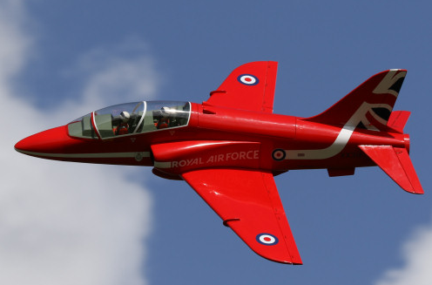
Specification
Wingspan: 1282mm / 50"
Length: 1307mm / 51"
AUW: 9.0lbs - 10.0lbs (4Kg-4.5Kg)
Wing Area: 3.39sq' (0.315m²)
Wing Loading: 43oz/sq.ft. (12.9kg/sq.m)
Fan: 90mm Fan (4.5Kg thrust)
Radio: 6 Function (7 Servos)
Battery: 8S 4000mAh - 5000mAh 40C

All supplied from Tony Nijhuis and the total cost today is £458 (retracts alone are £190).

<PICS>
Plan, build article with pictures, cut part wood pack, additional wood pack, pilots, nose cone, canopy, intakes and retractable landing gear £250
dave_gresham@hotmail.com
07971 426432

Mirage 2000C (39”)
MW3668 https://www.sarikhobbies.com/product/mirage-2000c-39/
A chance to build this classic French delta-wing fighter as either the single-seat ‘C’ version which can be powered by either a 90mm + EDF or a gas turbine, such as the Wren MW44 or 54.
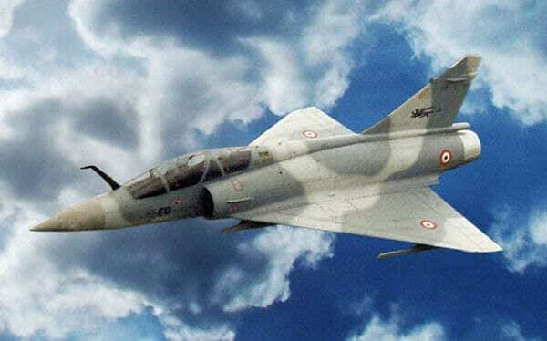
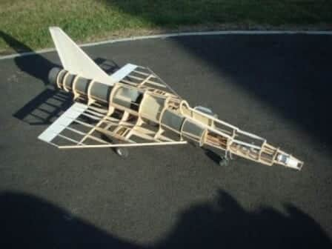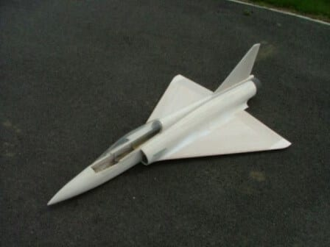
Specification
- Designer: Philip Noel
- Wingspan: 39″ (990 mm)
- Power Source: (Wren MW44/54 or similar)
- Radio Functions: Throttle, Elevons, rudder, U/C
- Length: 62.25″ (1,587 mm)
- Electric Power: 90 mm + EDF

Plan £26, Canopy £15, woodpack £147

Plans, cut part woodpack, canopy £100
dave_gresham@hotmail.com
07971 426432

Hawker Hunter FGA9 (48″)
MW3241 https://www.sarikhobbies.com/product/hawker-hunter-fga-9-48-2/

Chris Golds AFC has exquisitely modelled his favourite service aircraft in fine detail to 1:8.4 scale for EDF operation.

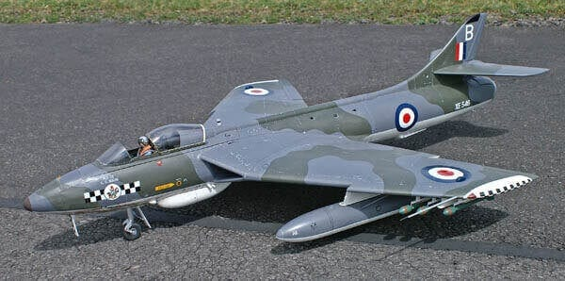

Specification
Designer: Chris Golds
Wingspan: 48″ / 1220 mm
Power Source: WeMoTec 90 mm
Radio Functions: 7-8 function
Scale: 1:8.4

Plan £29.50, wood pack £213

Plan and magazine, Cut part woodpack, £100
dave_gresham@hotmail.com
07971 426432

Westland Lysander (70”)
MW2545 https://www.sarikhobbies.com/product/westland-lysander-70/

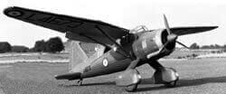

This classic WWII aircraft, designed by Duncan Hutson, makes a good flying school model. The plan gives full details of flaps and leading edge slats.
Plan £24.50, Woodpack £70, Canopy, cowl and wheel spats also available from Sarik.

Plan, Magazine with build article, cut part wood pack £40
dave_gresham@hotmail.com
07971 426432

Westland Lysander (81”)
MW3448 https://www.sarikhobbies.com/product/westland-lysander-81/
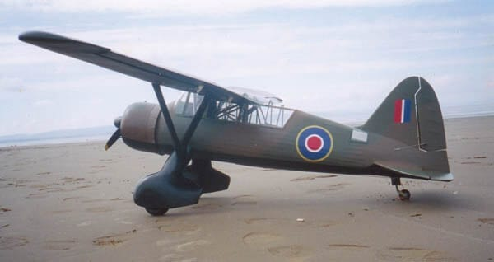
Specification
- Designer: Dennis Bryant
- Wingspan: 81″ / 2057 mm
- Power Source: .60 to .90 cu. in. 2-strokes; .90+ 4-strokes
- Power Source: IC Propeller
- Radio Functions: 5
- Scale: 1:7.4
- Weight: 5kg approx.

An 81” span WWII RAF STOL aircraft for .60 to .90-size engines and 5-function R/C. Superbly detailed on 3 large plan sheets from the Dennis Bryant Elite Plans range, the model is constructed from all wood and shows working flaps. This is probably the most famous of all STOL aircraft from WWII. Superbly detailed on 3 large plan sheets from the Dennis Bryant Elite Plans range, the model is constructed from all wood and shows working flaps. This is a builder’s model that is reasonably easy to fly for experienced pilots.
Plan £32.50, Woodpack £248

Cut part wood pack only £100
dave_gresham@hotmail.com
07971 426432

Mick Reeves Sopwith Pup (79”)
https://www.mickreevesmodels.co.uk/ww1-early-aircraft/

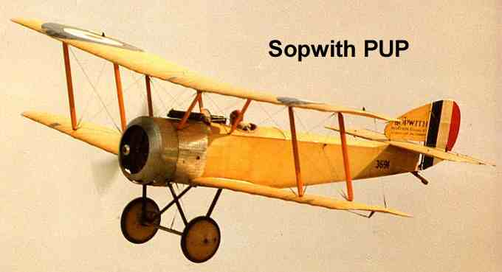

This was an earlier fighter than the Camel and was a delight to fly. Easy to dismantle as with our Camel.
1/4 Scale
French and Spanish National Champion.
Wingspan - 79 in (2.02m) Engine - 15cc to 30 cc
Weight - 151lbs (7kg)

Plans £40, Rib pack £70. More parts available from his website

Plans and cut parts rib pack only £40
dave_gresham@hotmail.com
07971 426432

Dassault Mirage 5/50 (43″)
MW2479 https://www.sarikhobbies.com/product/dassault-mirage-5-50-2/
Designed by Philip Noel. The configuration of this mark gives excellent slow-speed, take-off and climbing performance.
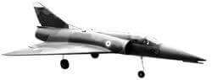
Specification
- Designer: Philip Noel
- Wingspan: 43″ /1090 mm
- Power Source: .45 2-stroke & 5″ tractor fans
- Radio Functions: 4 – 5

Plan £17.50, Canopy £15
Plans and canopy £15
dave_gresham@hotmail.com
07971 426432

Cessna Skyhawk (74″)
RM153 https://www.sarikhobbies.com/product/cessna-skyhawk-74/
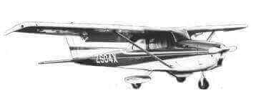

Designer: Arthur Warner Star Rating: *** Wingspan: 1879mm Engine Size: 0.60 R/C Functions: 6 Near scale and designed for sport flying, this one has bags of extra features. Workinq flaps and an optional parachute drop give this stable flyer more appeal than the average scale model. 74in. wingspan .. 50. Four to six function.
Plan £18, Cowl £11.50
Plan, cowl and copy of magazine article £15
dave_gresham@hotmail.com
07971 426432

